22 October 2024
National
WA agronomy consultant Geoff “Foz” Fosbery
receives national recognition
Renowned Western Australia agronomy consultant Geoff Fosbery is the recipient of the Australian Society of Agronomy’s 2024 C.M. Donald Medal.
Awarded by the Society at the 2024 Australian Agronomy Conference in Albany, WA, the C.M. Donald Medal celebrates eminent agriculturalists, recognising their long and distinguished career with contributions in all areas of agronomy including scientific and field research, development, and extension in Australia.
Geoff, or Foz as most know him, is a pioneer of independent agronomy services in WA. During 1992, Geoff took a leap of faith to establish himself as an independent agronomist. While common today, this fee-for-service approach was a new concept in agronomy and Geoff’s enthusiasm and energy not only made him an invaluable asset to many WA farmers but has blazed a trail for consultants ever since.
Australian Society of Agronomy President Dr Ben Biddulph said the landscape of agronomic consulting would look very different today if it had not been for Geoff and his dedication to assist farm businesses increase productivity.
“Geoff started his career in 1981 at the WA Department of Agriculture’s Dryland Research Institute in Merredin,” Dr Biddulph said.
“This was a time of great innovation, and a lot of research focused on developing better farming systems in areas with limited rainfall.
“During this time Geoff was instrumental in identifying the impact of soil acidity on reducing productivity, honing his extension skills and he became reputable for distilling messages from researchers to growers and encouraging on-farm adoption.
“This led Geoff to a very successful career as an independent consultant and he paved the way for many agronomists today.”
Geoff has always been on the cutting edge of research, development and extension, and is generous with his knowledge and experience. His constant pursuit of solutions to the problems of farming systems has been exemplary.
“It is not only Geoff’s engagement with growers that testifies to his strengths as an agronomist, but it is his connection with researchers themselves that sets him apart,” Dr Biddulph says.
“Geoff not only seeks out the latest development, but also to share his insights about how research fits in at a farm level. He has an extraordinary ability to bring together separate pieces of research and observations from growers and develop robust production systems in challenging environments, and this has been invaluable for our RD&E sector.”

No stranger to industry recognition, Geoff was awarded the Australian Institute of Agriculture ‘Award for Excellence’ during 2000 for his contribution to applied agricultural research and extension, his innovation and technical excellence and his lead role in a wide range of initiatives in agriculture.
The Grains Research and Development Corporation also recognised Geoff with the ‘Seed of Light Award’ during 2011, in recognition of going “above and beyond” in his agricultural research and extension endeavours.
As the 2024 C.M. Donald Medal recipient, Geoff joins the ranks of other distinguished agriculturalists including Adjunct Professor Brian Keating, Dr. John Angus and Prof. Timothy Reeves.
For more information visit the Agronomy Australia website www.agronomyaustralia.org

Contact Details:
Interviews | Dr Ben Biddulph  President, Australia Society of Agronomy  c/o office@agronomyaustralia.org.au  0428 920 654

More on the C.M. Donald Medal:
Colin Donald (1910-1985) profoundly influenced pasture development in Australia by understanding the limitations to pasture growth imposed by soils and environment and advanced our understanding of competition between plants when grown in communities. In recognition of the work of Colin Donald the Australian Society of Agronomy awards the C.M. Donald Medal for Agronomy to an eminent agronomist at each national conference of the Society. The C.M. Donald Medal is the most prestigious Australian award in Agronomy. In 1984. the Society instituted the C M Donald Medal to honour the contribution of Professor C M Donald to agricultural science.

More on the 21st Australian Agronomy Conference:
The 21st Australian Agronomy Conference, convened by the Australia Society of Agronomy, will be held in Albany, WA, from 21-24 October. The Conference is the premier biennial meeting that brings together industry professionals, researchers, and consultants and growers to discuss latest advancements on agronomy nationally. It serves as a platform for the exchange of knowledge, ideas, and experiences that contribute to the advancement of sustainable agricultural practices.
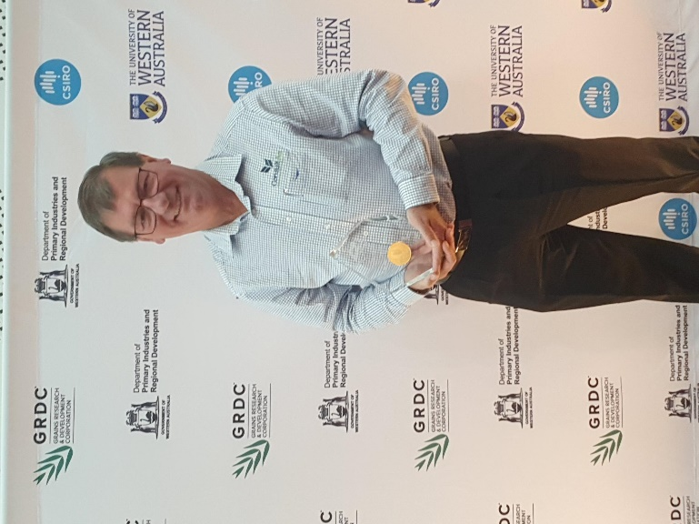
Picture caption: Recipient of the Australian Society of Agronomy’s 2024 C.M. Donald Medal is Western Australia agronomy consultant Geoff Fosbery.

